STUDENTS ACHIEVEMENT

S. No | Name | Group | Event | Award | Certificate
1 | J. Naveen | III B. A | Essay writing on the eve of National Consumer Day Celebrations at District Level | Secured I Place at District Level | 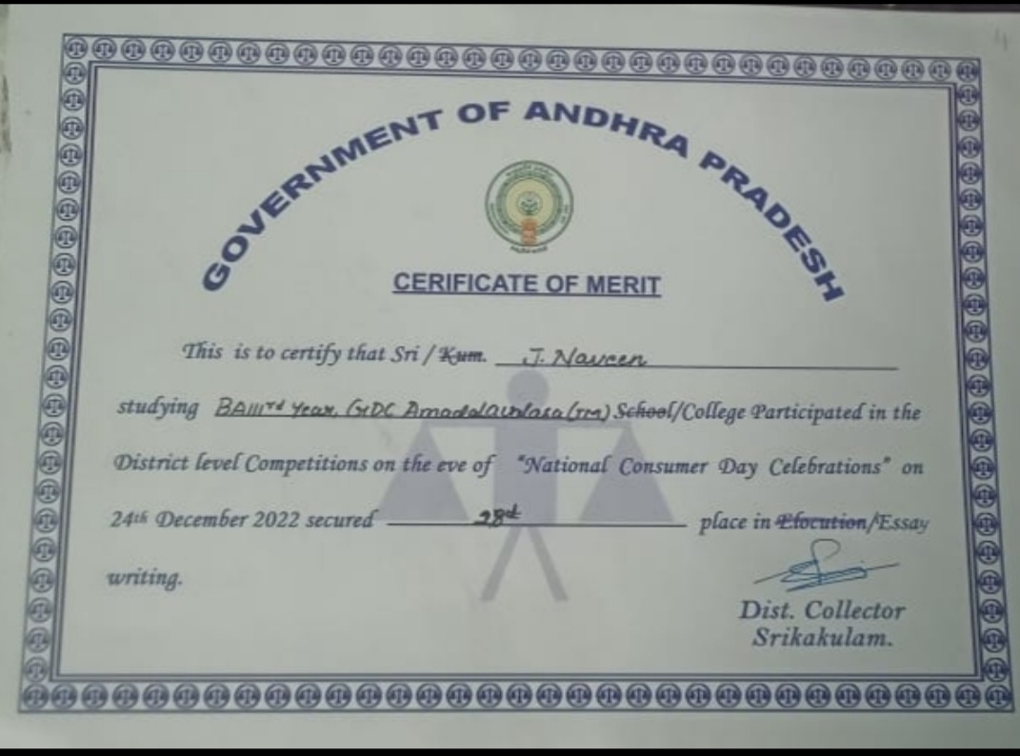
2 | J. Naveen | III B. A | Essay writing on the eve of National Consumer Day Celebrations at State level | Secured Consolation Prize at State Level | 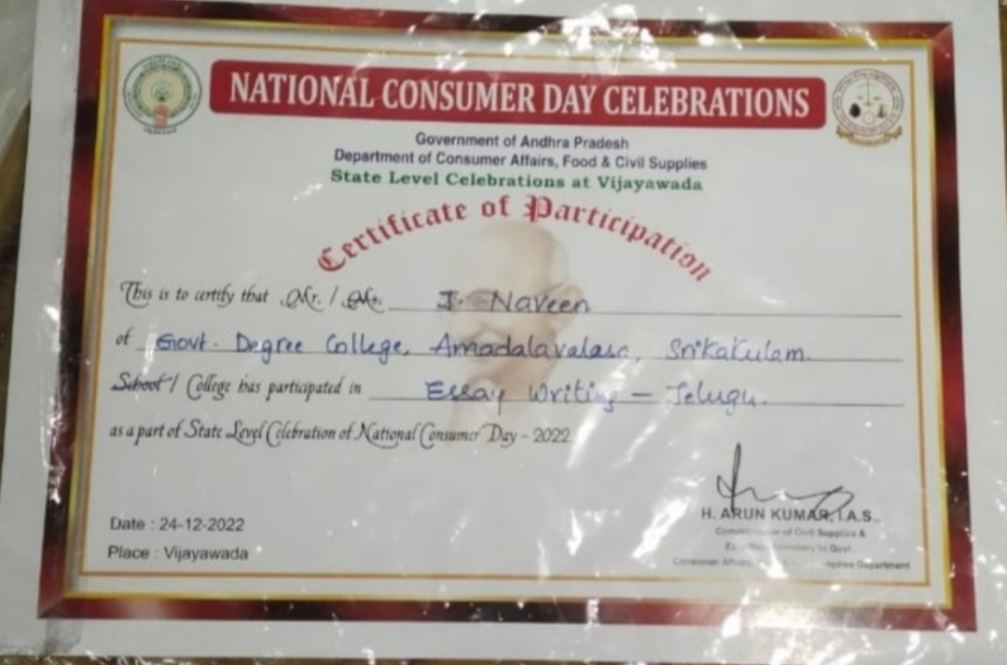
3 | S. Lokesh | III B. A | APPGCET | Secured 177th Rank in Economics | 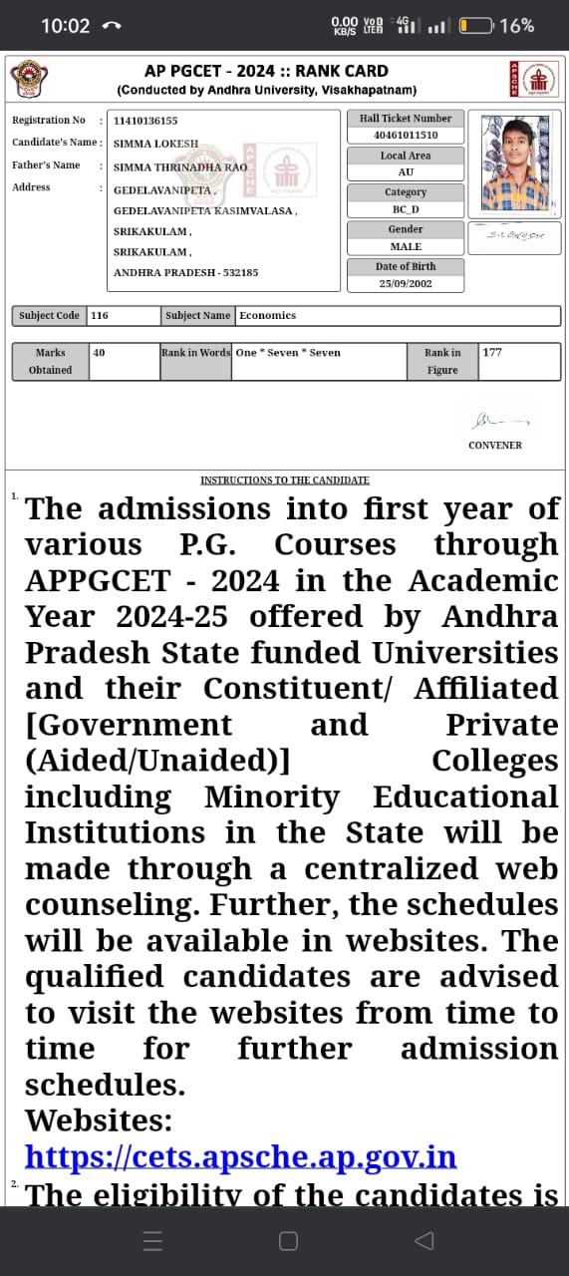
4 | B.Pavan Kalyan | II B. A | RBI Quiz | Participated | 